Assignment-3


K. R. MANGALAM UNIVERSITY BTech (AI & ML) SOET
(School of Engineering and Technology)

Name: MOHIT GOEL
Roll No: 2301730109
Course: Computer Networks Lab
Course Code: (ENCS304)
K. R. MANGALAM UNIVERSITY, SOHNA ROAD GURUGRAM, HARYANA

Experiment Objectives:
Create a network simulation to demonstrate RIP (Routing Information Protocol) and OSPF (Open Shortest Path First) using Cisco Packet Tracer. Compare the performance, convergence, and efficiency of both routing protocols by simulating data transmission across multiple network .

Learning Outcomes
- Apply routing concepts using RIP and OSPF
- Design and implement routing simulations in Cisco Packet Tracer
- Analyze routing tables and path selection
- Compare performance and convergence of routing protocols
- Evaluate routing behavior using simulation mode

Logical structure should include:
- Network Devices: Routers, Switches, PCs
- Network Connections: Copper cables
- Routing Protocols: RIP and OSPF
- Data Flow Simulation: Packet transmission between networks

Linear Topology :
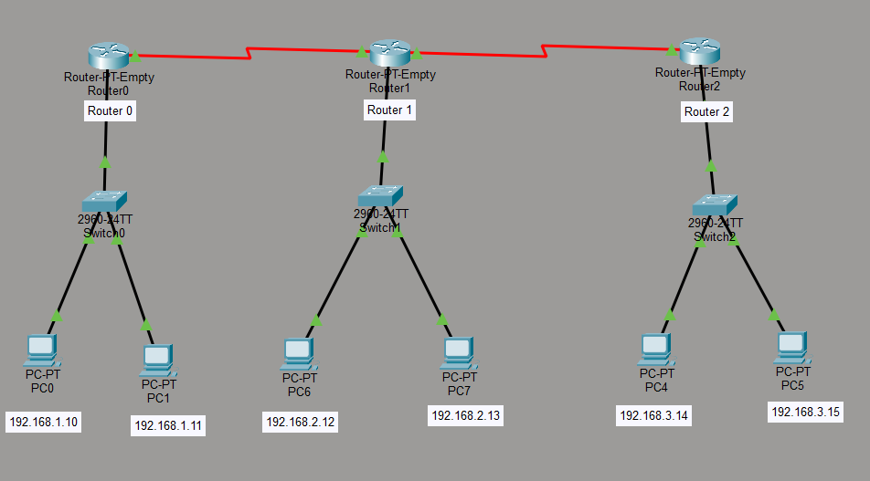

Triangle Topology :
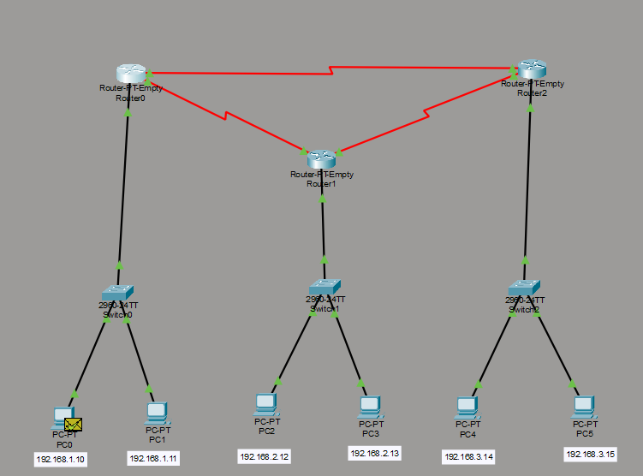

Routing Tables:
1. Triangle Topology
🔹 RIP Routing Table
Copper Straight-Through Connections
From | To | Port/Interface
PC0 | S1 | fa0/1
PC1 | S1 | fa0/2
S1 | R0 | fa0/24 → fa2/0
PC2 | S2 | fa0/1
PC3 | S2 | fa0/2
S2 | R1 | fa0/24 → fa2/0
PC4 | S3 | fa0/1
PC5 | S3 | fa0/2
S3 | R2 | fa0/24 → fa2/0
Serial DTE Connections
From | To | Port/Interface
R0 | R1 | se0/0 ↔ se1/0
R1 | R2 | se0/0 ↔ se1/0
R0 | R2 | se1/0 ↔ se0/0

🔹 OSPF Routing Table
Copper Straight-Through Connections
From | To | Port/Interface
PC0 | S1 | fa0/1
PC1 | S1 | fa0/2
S1 | R0 | fa0/24 → fa2/0
PC2 | S2 | fa0/1
PC3 | S2 | fa0/2
S2 | R1 | fa0/24 → fa2/0
PC4 | S3 | fa0/1
PC5 | S3 | fa0/2
S3 | R2 | fa0/24 → fa2/0
Serial DTE Connections
From | To | Port/Interface
R0 | R1 | se0/0 ↔ se1/0
R1 | R2 | se0/0 ↔ se1/0
R0 | R2 | se1/0 ↔ se0/0

📘 2. Linear Topology
🔹 RIP Routing Table
Copper Straight-Through Connections
From | To | Port/Interface
PC0 | S1 | fa0/1
PC1 | S1 | fa0/2
S1 | R0 | fa0/24 → fa2/0
PC2 | S2 | fa0/1
PC3 | S2 | fa0/2
S2 | R1 | fa0/24 → fa2/0
PC4 | S3 | fa0/1
PC5 | S3 | fa0/2
S3 | R2 | fa0/24 → fa2/0
Serial DTE Connections
From | To | Port/Interface
R0 | R1 | se0/0 ↔ se1/0
R1 | R2 | se0/0 ↔ se1/0

🔹 OSPF Routing Table
Copper Straight-Through Connections
From | To | Port/Interface
PC0 | S1 | fa0/1
PC1 | S1 | fa0/2
S1 | R0 | fa0/24 → fa2/0
PC2 | S2 | fa0/1
PC3 | S2 | fa0/2
S2 | R1 | fa0/24 → fa2/0
PC4 | S3 | fa0/1
PC5 | S3 | fa0/2
S3 | R2 | fa0/24 → fa2/0
Serial DTE Connections
From | To | Port/Interface
R0 | R1 | se0/0 ↔ se1/0
R1 | R2 | se0/0 ↔ se1/0

📘 Simulation of Network Operation
🔹 Simulation Mode in Cisco Packet Tracer
The network was tested using Simulation Mode in Cisco Packet Tracer to observe how packets travel between devices.
Steps performed:
- Switched from Real-Time Mode → Simulation Mode
- Selected ICMP (ping packets) from the event list
- Sent a ping from PC0 to PC3 (192.168.2.13) and PC4 (192.168.3.14)
- Used the “Capture/Forward” button to track packet movement step-by-step

🔹 Working of RIP (Simulation)
When using Routing Information Protocol (RIP):
- Initial Packet Drop
  - The first ping packet is sometimes lost
  - This happens because routers are still learning routes
- Routing Table Exchange
  - Routers exchange full routing tables periodically
  - Each router updates its table using hop count
- Packet Flow
  - Packet travels:
    - PC0 → S1 → R0 → R1 → Destination (PC3)
  - For longer path:
    - PC0 → R0 → R1 → R2 → PC4
- Observation
  - Slower packet delivery initially
  - More delay due to periodic updates

🔹 Working of OSPF (Simulation)
When using Open Shortest Path First (OSPF):
- Fast Convergence
  - Routers quickly share link-state information
  - Network map is built faster
- Shortest Path Selection
  - OSPF selects path based on cost (bandwidth)
  - Always chooses optimal route
- Packet Flow
  - Packet directly follows the best path
  - If multiple paths exist, best one is chosen
- Observation
  - Faster response compared to RIP
  - Less unnecessary traffic

🔹 Step-by-Step Packet Flow (Example)
Ping: PC0 → PC4 (192.168.3.14)
Step | Device | Action
1 | PC0 | Sends ICMP request
2 | S1 | Forwards to R0
3 | R0 | Checks routing table
4 | R1 | Forwards packet
5 | R2 | Sends to destination network
6 | PC4 | Receives and replies
7 | Reverse Path | Reply returns to PC0

Output:
Routing Information Protocol (RIP)
🔹 Route Table
Copper Straight-Through Connections
From | To | Port/Interface
PC0 | S1 | fa0/1
PC1 | S1 | fa0/2
S1 | R0 | fa0/24 → fa2/0
PC2 | S2 | fa0/1
PC3 | S2 | fa0/2
S2 | R1 | fa0/24 → fa2/0
PC4 | S3 | fa0/1
PC5 | S3 | fa0/2
S3 | R2 | fa0/24 → fa2/0
Serial DTE Connections
From | To | Port/Interface
R0 | R1 | se0/0 ↔ se1/0
R1 | R2 | se0/0 ↔ se1/0

🔹 Ping Result 1 (192.168.2.13)
Packet | Result | Time | TTL
1 | Reply | 1 ms | 126
2 | Reply | 2 ms | 126
3 | Reply | 2 ms | 126
4 | Reply | 11 ms | 126
Statistics
Metric | Value
Sent | 4
Received | 4
Lost | 0 (0%)
Minimum Time | 1 ms
Maximum Time | 11 ms
Average Time | 4 ms

🔹 Ping Result 2 (192.168.3.14)
Packet | Result | Time | TTL
1 | Timeout | — | —
2 | Reply | 11 ms | 125
3 | Reply | 10 ms | 125
4 | Reply | 12 ms | 125
Statistics
Metric | Value
Sent | 4
Received | 3
Lost | 1 (25%)
Minimum Time | 10 ms
Maximum Time | 12 ms
Average Time | 11 ms

📘 Open Shortest Path First (OSPF)
🔹 Route Table
Copper Straight-Through Connections
From | To | Port/Interface
PC0 | S1 | fa0/1
PC1 | S1 | fa0/2
S1 | R0 | fa0/24 → fa2/0
PC2 | S2 | fa0/1
PC3 | S2 | fa0/2
S2 | R1 | fa0/24 → fa2/0
PC4 | S3 | fa0/1
PC5 | S3 | fa0/2
S3 | R2 | fa0/24 → fa2/0
Serial DTE Connections
From | To | Port/Interface
R0 | R1 | se0/0 ↔ se1/0
R1 | R2 | se0/0 ↔ se1/0
R0 | R2 | se1/0 ↔ se0/0

🔹 Ping Result 1 (192.168.2.12)
Packet | Result | Time | TTL
1 | Timeout | — | —
2 | Reply | 1 ms | 126
3 | Reply | 11 ms | 126
4 | Reply | 3 ms | 126
Statistics
Metric | Value
Sent | 4
Received | 3
Lost | 1 (25%)
Minimum Time | 1 ms
Maximum Time | 11 ms
Average Time | 5 ms

🔹 Ping Result 2 (192.168.3.14)
Packet | Result | Time | TTL
1 | Timeout | — | —
2 | Reply | 11 ms | 125
3 | Reply | 32 ms | 125
4 | Reply | 10 ms | 125
Statistics
Metric | Value
Sent | 4
Received | 3
Lost | 1 (25%)
Minimum Time | 10 ms
Maximum Time | 32 ms
Average Time | 17 ms

